Barnwell Elementary Physical Education
Week of March 30 – April 3

K-2nd Grade
 | Digital | Non-Digital
Choose either a digital or non-digital activity | Click on the links within this column to go digital.  Choose at least one activity for each day that it is your scheduled physical education class. | If you do not have access to digital or prefer, use this column of activities for your work. It is recommended to get physical activity daily so for an added challenge, choose one of the activities each day of the week. Have FUN!
Fitness | Click link below for a fitness workout on YouTube.  Family Workout | Put on some music and do the below workout!  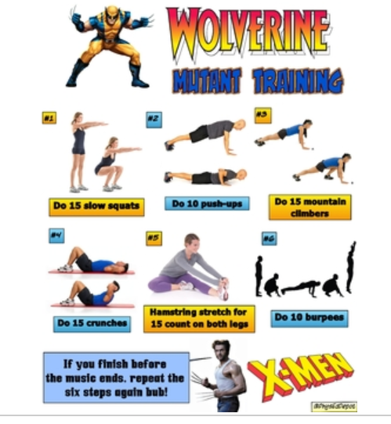
Sports  Skills | Ladder Drills  Click link for ladder drills. Use chalk or tape to make a ladder. Roll dice to pick which drill to do or just do them in order. Move on to the next if no mistake is made.  Ladder Drills | Ladder Drills  Use diagram below for ladder drills. Use chalk or tape to put a ladder on the ground.  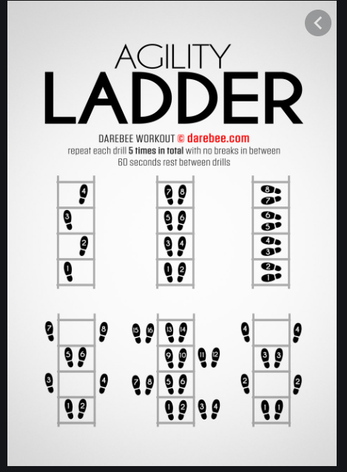
Dance | Dance Grid  Click link below and spin wheel do each dance for 30 seconds. Then spin again!  Dance Grid | Family Dance Party  Put on some music and have a family dance party!
DEAM  April Calendar | Drop Everything And Move  April Calendar | Each day of the week, choose your own way to move.  Physical activity has many benefits including stress relief, physical fitness, improved coordination and many more. Find a way to move most every day of the week.

Grades 3 - 5
 | Digital | Non-Digital
Choice of Digital or Non-Digital | Choose one activity from this column if you have digital connections. To challenge yourself, choose one everyday of the week, not just your PE days. | Choose one activity from this column if you have do not have digital access. To challenge yourself, choose one everyday of the week, not just your PE days.
Fitness | Click link below for a fitness workout on YouTube.  Family Workout | Put on some music and do the below workout!
Sports  Skills | Ladder Drills  Click link for ladder drills. Use chalk or tape to make a ladder. Roll dice to pick which drill to do or just do them in order. Move on to the next if no mistake is made.  Ladder Drills | Ladder Drills  Use diagram below for ladder drills. Use chalk or tape to put a ladder on the ground.
Dance | Dance Grid  Click link below and spin wheel do each dance for 30 seconds. Then spin again!  Dance Grid | Family Dance Party  Put on some music and have a family dance party!
DEAM  April Calendar | Drop Everything And Move  April Calendar | Each day of the week, choose your own way to move.  Physical activity has many benefits including stress relief, physical fitness, improved coordination and many more. Find a way to move most every day of the week.

