Kindergarten Week 4 Lessons
Please pick one subject per day. Watch the lesson (extra resources are optional) and complete the activity.
Then pick one activity from the weekly choice board for review of previously taught material.
Morning Meeting: Student will attend morning meeting daily. | https://docs.google.com/presentation/d/1mtryVH9dzK3mvliYBDRsczquEfh0JBsjWynjEEkLWDY/edit?usp=sharing

Writing: Nonfiction Animal Research Writing
Standards: RFK1, RFK1a, RlK1, WK2  Lesson:  Click here to access the video lesson  https://drive.google.com/file/d/1rBu7gibjKDbKnOcnaik5VobHwTUwmhYH/view  The teacher will explain what a research project is. The teacher will read a nonfiction passage about giraffes. The teacher will model how to create a graphic organizer with students using the words: are, can, have, eat, live, like. The teacher will model how to take the information from the graphic organizer and write a book.  Extra resources:  Any nonfiction books | Materials needed:  Blank piece of paper for graphic organizer  Paper stapled together for book  Pencil and crayons  Activity:  - Pick a nonfiction book or passage  - Make a graphic organizer  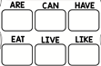  - Use the graphic organizer to write a nonfiction book about an animal.  - Illustrate your book  - Upload a video of you reading your book to seesaw, so your teacher can see.
Phonics: Letter Zz
Lesson: RFK2d, RFK3  We will do the 3-part drill (identify letters, sounds and blend CVC words.) We will listen and identify the new letter in sentences. Click below for video lesson, handwriting paper and The Gruzzle poem.  https://drive.google.com/drive/folders/1QOyT_5CksROCRvqiz-I4LoGHrBx8IjxD?usp=sharing  Extra resources:  If I Ran the Zoo | Materials needed: Attached paper, green crayon,  Activity: Practice writing the letter of the week using the correct format. Write and illustrate 3 or more words with the letter of the week. 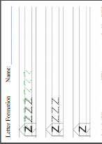  Optional: Upload a picture of your list to Seesaw and record yourself reading the words.
Math: Strategies to Decompose Numbers
Standard: MCCK.OA.3  Lesson: Click here to access the video lesson  https://drive.google.com/file/d/1Gwlit7BUDoq50arwG4Jwmg6eAshEuoGH/view  The teacher will explain the definition and importance of decomposing numbers. The teacher will explain and provide models of a variety of strategies to use to decompose a number: manipulatives, Whole-Part-Part Mats, and Number Bonds. The teacher will provide practice examples using each strategy for students to complete. The teacher will review the strategies for students to use when decomposing a number. The teacher will explain the assignment. The students will decompose numbers by creating their own number bonds.  Extra resources:  Roll and Create Number Bond Paper:  https://fultonk12-my.sharepoint.com/:w:/r/personal/collins_fultonschools_org/_layouts/15/Doc.aspx?sourcedoc=%7BECDAFE3D-96F6-4113-9F34-9D1FE53D82D4%7D&file=Decompose%20a%20number%20using%20number%20bonds.docx&action=deult&mobileredirect=true  Videos:  https://www.youtube.com/watch?v=ICRiPnDink4  https://www.youtube.com/watch?v=9JtrgMFWYaM  https://www.youtube.com/watch?v=WAR-Ub9tPvo | Activity: Decompose numbers by creating your own number bonds.  Draw a number bond on blank paper (or print the paper). Pick a number.  To get the number (Whole) you can: Roll a dice, pick a playing card, make number cards 1-10, or choose a number of your own.  Write number in top circle (Whole) of number bond. Break the whole number into 2 parts.  What 2 parts are the same as (or equal to) the whole?  Write the 2 numbers (parts) in the bottom circles of number bond. Repeat procedure for each number bond.  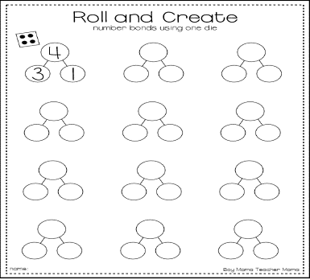  Optional:  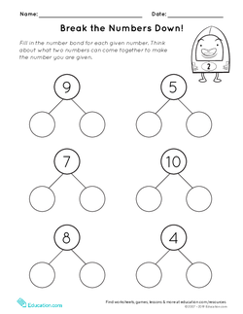
Reading: Main Idea and Details in Non-Fiction Texts
Standards – KRI2  Lesson: Click here to access the video lesson  https://flipgrid.com/0ae2932b  We will use an anchor chart to discuss the meaning of main idea and supporting details. We will also look at graphic organizers, completed with supporting detail pictures, and brainstorm the main idea.  Extra resources:  Nonfiction books | Activity: Select a nonfiction book from home (or available on Epic) to read. After reading the book, create a main idea/supporting details organizer. Write the main idea in the middle circle and either draw or write at least 3 supporting details from the text.  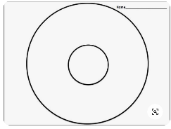  Optional: Upload a picture of your organizer to Seesaw for your teacher to see.
Science – Animals Can Have Young
Lesson: SKL2  The teacher will introduce that adult animals can have young. The teacher will share a presentation on animal families that illustrates what an animal family looks like. Similarities and differences between parents and offspring will be discussed  Extra resources: Epic Books, videos included on the YouTube link.  Click on link to access a presentation on Animal Families  https://docs.google.com/presentation/d/1u6s902dbx7c1uhsoByuutSC5laAfrrPjOrqb6RDNHUQ/edit?usp=sharing | Activity 1  Students will watch a presentation on animal families. Students will use a blank sheet of paper to create a chart showing a picture or a drawing of an adult animal in the first column and then compare how alike and different they are from their parent in the second and third column.  Animal Parents and their Offspring  Animal Alike Different  Activity 2 – Students will match animal parents with their babies/offspring. Students can upload their picture to Seesaw.  Activity 3 – Students will read or listen to story, Are You My Mother? And answer questions about the story.

