Kindergarten English Language Arts

For the 4th week of TeleSchool, choose and complete one activity per day.
Reading (Informational)  Select an informational book to read. After your second read, answer the following questions with pictures or words on a separate piece of paper:  - What is the main topic of the book?  - Use pictures or words to write down two facts you learned. | Reading (Technology)  iReady (available on Fulton County Student Launchpad).  iReady lessons for 20-30 minutes. | Phonics and Writing  You have been studying different consonant digraphs (two letters that spell one sound) the last few weeks including sh, ch, and th. Read the poem, The Hungry Chicken, once. Then reread it and underline all of the words with the digraph ch.  - What do you notice about these words?  - Is there a pattern that each follows?  - Write 3-5 of your own ch words using what you have learned about this consonant digraph?  - Create your own poem or song using your ch words.  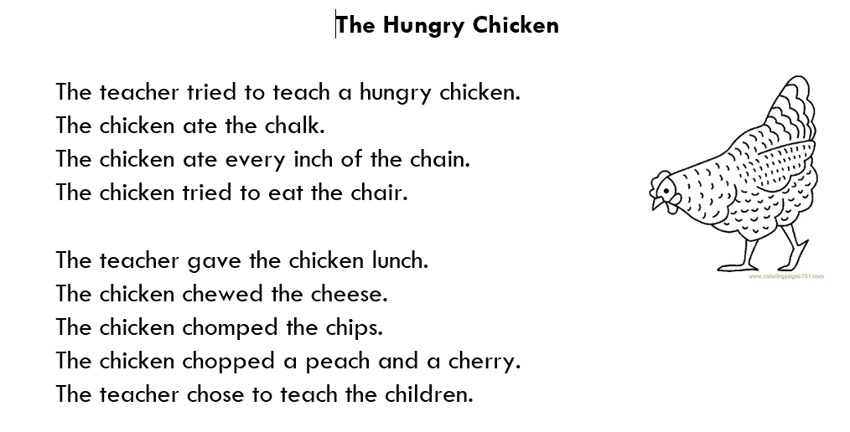

Reading (Oral Language & Partnership Work)  Select a book from your home or library to read with a partner. Choose different ways to read the book together with your partner located on the anchor chart.  - Record yourself reading with a device (phone, ipad, tablet) and then listen to the recording while following along in your book.  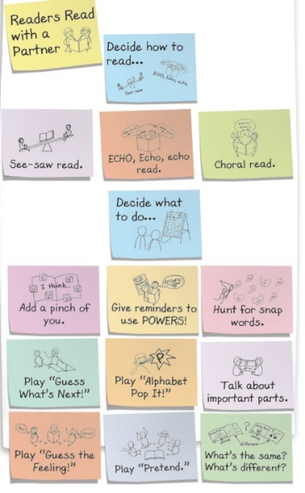 | Complete a Seesaw activity and submit. | Phonics and Writing  We’ve been working on our short o word families. Read through the poem, Pirate Play , and highlight all the -ot words. On a separate sheet of paper, brainstorm 5 -ot words and use each one in a sentence.  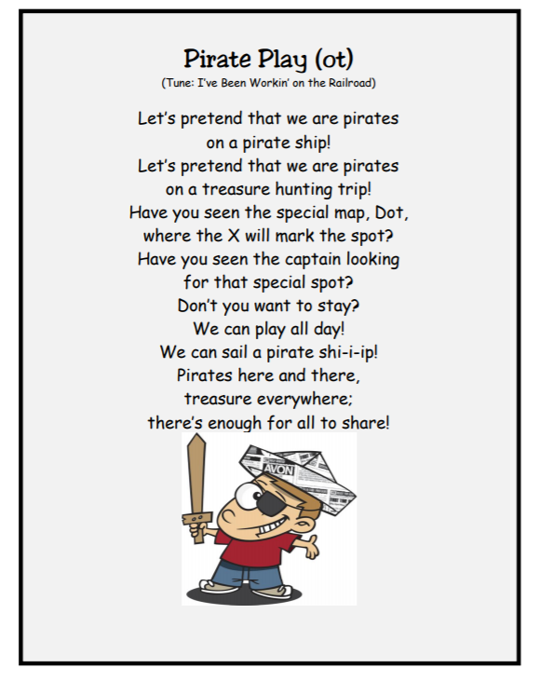
Independent Reading  (Your Choice!)  Select a book of your choice and independently read for 20 minutes. Share your review of the book with a friend or caretaker. | Writing  Write a letter to your teacher telling her why we should or should not wash our hands.  - Include some reasons to support your opinion (I think this because…)  - Be convincing! (Get your teacher to listen to you )  - Write as long and strong as you can | Phonics  Create your own Snap Word Puzzles.  Write the words listed below on a separate piece of paper. Cut out each word. Then cut each word into individual letters. Mix up the letters and put back together to re-create the word. Write sentences using 3 of the words.  Make With Saw  Say What Was  Down That Are
Kindergarten English Language Arts

Kindergarten Math

For the 4th week of TeleSchool, choose and complete one activity per day.
Count out loud to 100 by 1’s, 10’s and 5’s.  Count on from a given number to 100.  24  36  59  78  (For example, put the number in your head and start counting with the number that comes after…  25, 26, 27, 28, 29….) | Log into iReady MATH for 20 minutes | Complete a seesaw activity and submit.
Visit www. starfall.com  Play any of the math games available on the website.  Username: henrichm@fultonschools.org  Password: barnwellpse | Addition Fact Fluency within 5  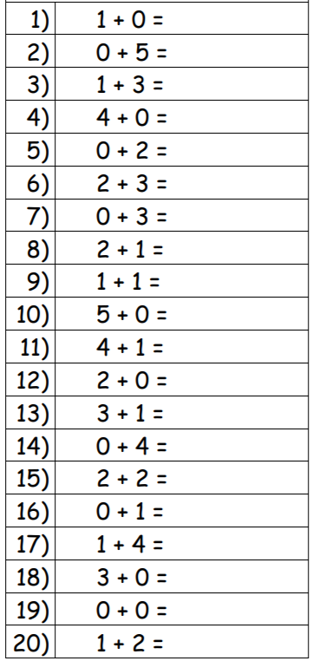 | True Addition Statements  On a separate sheet of paper solve the problems using pictures or objects. Circle the ones that are true and cross out the ones that are false.  7 + 2 = 9 3 + 6 = 4  10 = 3 + 7 5 = 4 + 9  9 + 1 = 10 4 + 4 = 8
Show different ways to represent the number 25.  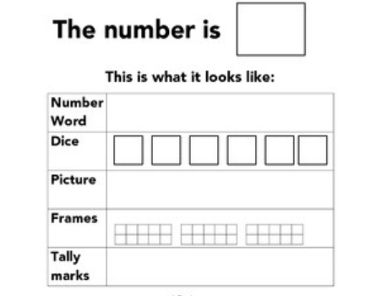 | Solve the following missing addend problems using an addition strategy.  4 + ___ = 10 7 = 5 + ___  3 + ___ = 6 9 = 3 + ___  ___ + 4 = 9 5 = ___ + 1 | Count out 9 objects. How many ways can you decompose the number 9?  