Barnwell Digital Learning TAG K-2

Directions:
Choose at least one activity to extend your learning for this unit.

Research a topic of interest from your current unit.  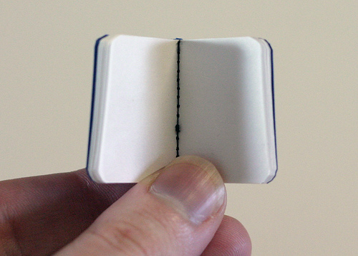  Make a mini book to share your information. | Write a newspaper article about something that you’ve learned in your TAG class this year.  This Photo by Unknown Author is licensed under CC BY  Create an illustration to go with your article. | Create a new tool that will clean the roads during a snow storm. Explain how your tool will work, and who will use it.
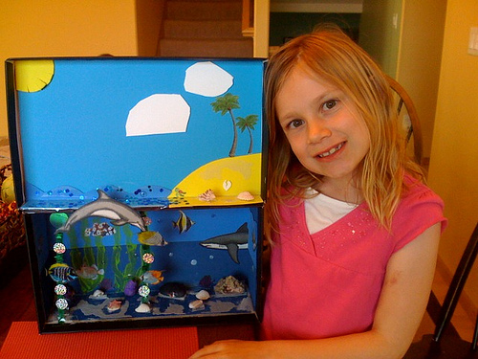  Make a diorama of a winter scene. Include all of animals or plants that live there. You can use clay, paper or other materials you can find. Be creative! | 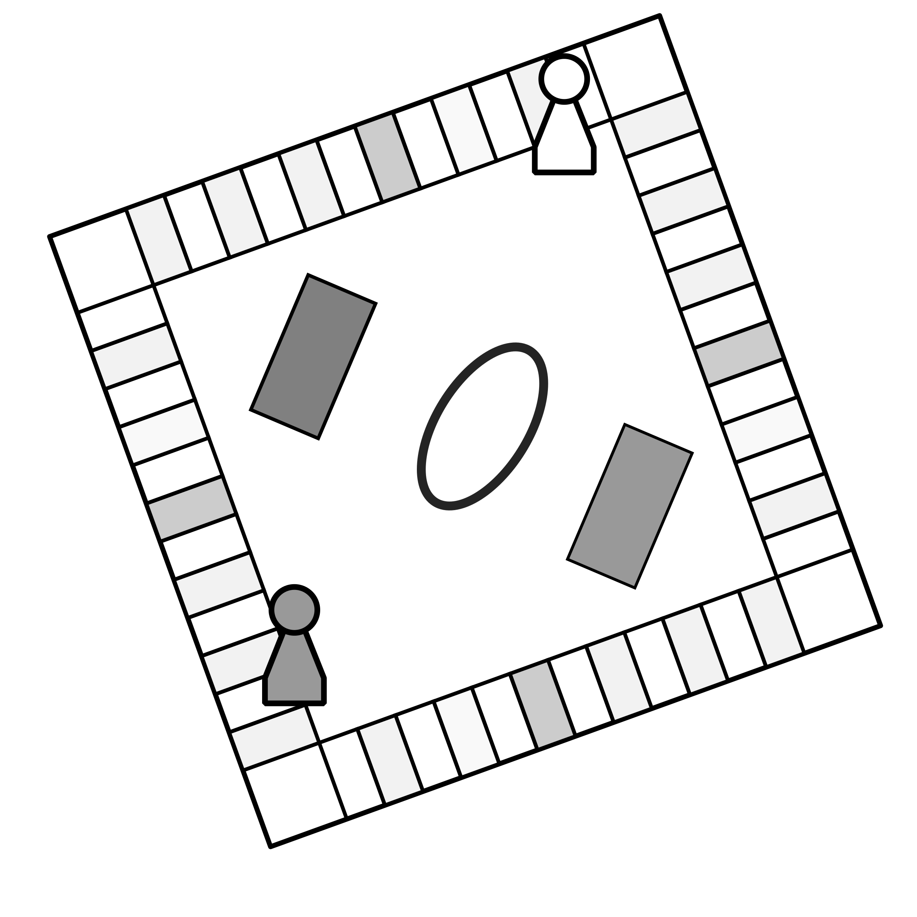  Create a game that will teach others what you have learned in TAG. | 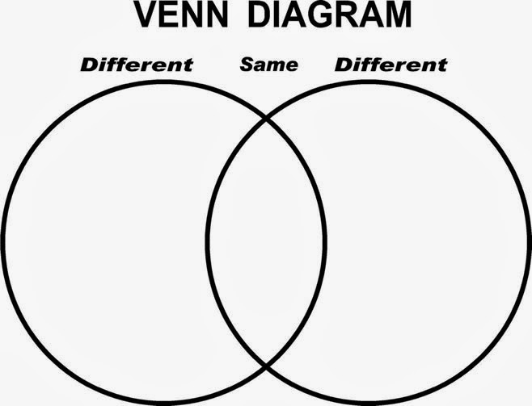  Research and then Compare and Contrast two winter holidays. Make a VENN DIAGRAM to record your findings.
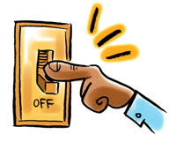  Brainstorm all the problems that your family might face if they lost power during a storm. Choose two of your problems, and give a solution for each one. | Create a poem or song about winter and how it makes you feel. | Write a creative story about your adventures during a snow storm.  