Art Choice Board K-2
Please choose 1 of the 6 lessons below to complete per week. Complete and save your work to be turned in when we return to school or submit it to the link that will be sent to you at the beginning of the week by Mrs. Robinson (Hudson).

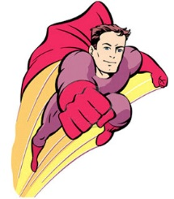  Create a superhero and design an outfit for them. Color in with crayons, markers, oil pastels, colored pencils, etc. | Trace your hand with a pencil and fill it in with at least 6 different patterns.
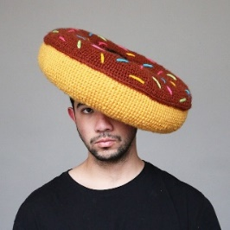  Draw a self-portrait, of you wearing a hat made out of your favorite food. Add color. | Watch this video on youtube  about the artist Kandinsky, and then draw a picture while listening to music.  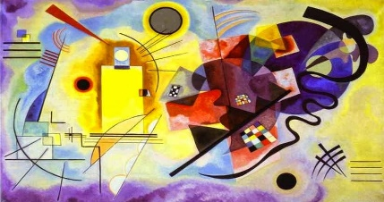  This Photo by Unknown Author is licensed under CC BY-SA-NC
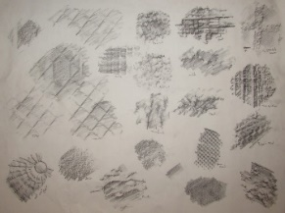  Use a crayon or oil pastel to create 4 different texture rubbings of textures you find in your house. Place your paper on top of the texture and rub with the side of the crayon. | 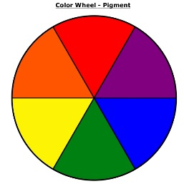  Watch this video on colors. After the video draw and color in a picture of your favorite story, then label all of the primary colors in your picture.

