Art Choice Board 3-5
Please choose 1 of the 6 lessons below to complete per week. Complete and save your work to be turned in when we return to school or submit it to the link that will be sent to you at the beginning of the week by Mrs. Robinson (Hudson).

Choose 5 different animals, then taking one feature of each animal I want you to create a new type of creature and give it a name. This creature should be colored in. (ex: monkey tail, horse head, chicken body, giraffe legs, and elephant ears) | Draw a family portrait including all family members and pets. Then draw in an unexpected background (outer space, the jungle, surrounded by giant food etc.) Color with any art materials.
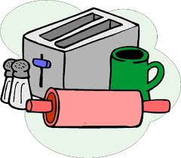  Find 3 objects in your house and draw all 3 objects from observation. Then color with unexpected colors and patterns. (ex: yellow polka dot house plant) | Take a picture walk. Get a camera, take 20 steps in any direction, then find an interesting view point and take a picture. Repeat this until you have 5 different pictures taken.
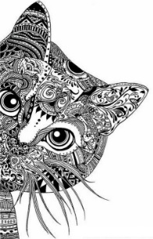  Draw an animal zentangle. Draw the outline of any animal and fill it with patterns and designs to create the textures and details of the animal. You can keep it black and white or add color,  Artists choice! | 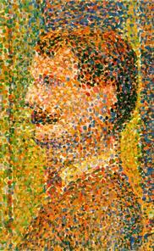  Watch this video about artist George Seurat, then draw a self portrait using only colored dots to fill it in.

