Resource Guide
Study Island Access
http://www.studyisland.com/login (Study Island for Schools)
Username: 10 digit ID
Password: 10 digit ID
Lessons-- GA Programs (Math OR RELA)
Assignments-- My Class > View Assignments

Reflex Access
https://www.reflexmath.com/

Seesaw Access
https://launchpad.classlink.com/fcs
Username: 10 digit ID
Password: 8 digit birthday

BrainPop Jr.
https://launchpad.classlink.com/fcs

Additional Resources:
iReady Math and Reading (Classlink)
Learning.com (Classlink)
Greg Tang Math
Mystery Science: https://mysteryscience.com/school-closure-planning
MyON: https://www.myon.com/login/index.html
School: Get Georgia Reading
Username: fultoncounty
Password: read

2nd Grade At Home Learning Calendar
Use this calendar to help keep yourself organized during our days of remote learning. Each day, follow the schedule. Check off each item as you do it. Place all completed paperwork in a folder to bring to school with you when we return.

 | Monday | Tuesday | Wednesday | Thursday | Friday
BBTV Morning News | http://barnwelldigital.weebly.com/bbtv.html
Reading | - Complete Study Island Assignment on Main Idea  - 20 minutes of Iready Reading | - Complete the Prefix activity  - Complete Study Island Assignment on Shades of Meaning  - Read 20 minutes | - Complete Comparing Solids Activity  - Complete “Fix the Sentences” activity  - 20 minutes of iReady Reading | - Complete Compare and Contrast activity  - Read 20 minutes and answer questions from the choice board | - ReadWorks Assignment: Characters and Their Pets  - Complete a Seesaw Activity
Writing | - Choose a topic for a Narrative (Fictional or personal)  - Write the lead for your narrative | - Tootle Tuesday Padlet https://padlet.com/whiteheads1/tootletuesday  - Write the beginning part of your narrative | - Write the middle part of your narrative | - Write the ending for your narrative | - Revise and edit your narrative.  *If you can, post on Seesaw to share with your teacher!
Math | - Complete money word problems  - Complete MGSE2.NBT.3 activity | - Complete Study Island Assignments on Addition and Subtraction Word Problems and time.  - 20 minutes of iReady Math | - Complete MGSE2.OA.2 activities  - Complete a Seesaw Activity | - Complete MGSE2.NBT.7 activity  - 20 minutes of iReady Math | - Complete Study Island Assignment on Graphs  - Complete MGSE2.OA.1 activity
Extensions | - Create a board game for your math unit  - Write a new ending for a fiction book you’ve read  - Greg Tang Tangy Tuesday Packet  - Reading Bingo Board- located on the Media Center tab on Barnwell’s Digital Learning  website

Grade 2 Math Week 3
MGSE2.MD.8  Solve word problems involving dollars bills, quarters, dimes, nickels, and pennies, using $ and appropriately.  - Scarlett has $5.60 and her sister gives her 2 quarters. How much money does Scarlett have?  - Ella has 4 one-dollar bills, 3 quarters and 5 dimes. Logan has 1 five-dollar bill and 1 nickel. Who has more money?  - Owen has $2.35 and he spends 1 dime and 3 nickels. How much money does he have?  - Dan has 2 one-dollar bills, 1 quarter and 2 dimes. Joe has 3 one-dollar bills and 3 nickels. After Joe gives Dan all his coins, who has less money? | MGSE2.OA.2  PRACTICE ALONE:  - Make 2 sets of digit cards (0-9)  - Draw two cards making a two-digit number (24, 34, 56…)  - Draw one more card making a one-digit number (2, 5, 8…)  - Add the two numbers together mentally  - Continue to play until sums become automatic  PARTNER PLAY:  - Play with the same directions as above  - The player that says the sum first gets a point  - First player to reach 10 points wins that round | M.OA.1  Complete the Study Island assignment, Math Addition and Subtraction Word Problems
MGSE2.NBT.7  Use place value block drawings to solve the following problems.  - 307 - 254  - 613 + 207  - 523 - 326  - 458 + 344  Create a word problem for each problem.  Re-check your answer with inverse operation. | MGSE2.NBT.3  Write these numbers in word form, expanded form, and base-ten numbers.  - 408  - 357  - 189  - 215  - 948 | MGSE2.OA.2  Subtract these problems.  - 45-18  - 276-107  - 492-218  - 105-76  Create a word problem for each problem.  Re-check your answer with inverse operation.
MGSE2.MD.7  Complete the Study Island Assignment on Time. | MGSE2.OA.1  Create 4 words problems and solve them 4 different ways. Use models and equations to represent the problems….show all your work. | 2.MD.10  Complete the Study Island Assignment on Graphs.

Grade 2 RELA Week 3
ELAGSE2RI2 and ELAGSE2RI8  Complete the Study Island Assignment on Main Idea. | ELAGSE2L5  Complete the Study Island Assignment on Shades of Meaning. | ELAGSE2RL2: Read 20 minutes  - Read a fictional text of your choice.  - After reading, answer the following questions:  *What is the genre of the book? How do you know?  *What is the author’s message in the book?  *What is the most important part in the story? Why?  *How does the character change in the story?
ELAGSE2W3  Write a narrative (fictional or personal).  Don’t forget to include: beginning, characters, setting, dialogue, transition words, problem/solution, and ending. | ELAGSE2L4  Define the following words using their prefixes. Choose 5 words to use in a sentence.  un,dis,non (not)  pre (before)  re (again)  bi (two)  unfair  uneven  disobey  disagree  nonfiction  preschool  pretest  refill  rewrite  bicycle | ELAGSE2RL9: Compare and Contrast  Listen to: The True Story of the Three Little Pigs  The True Story of the Three Little Pigs  Then, log in to MyOn: (directions on resource page) and search for the book: No Lie, Pigs (And Their Houses) Can Fly!  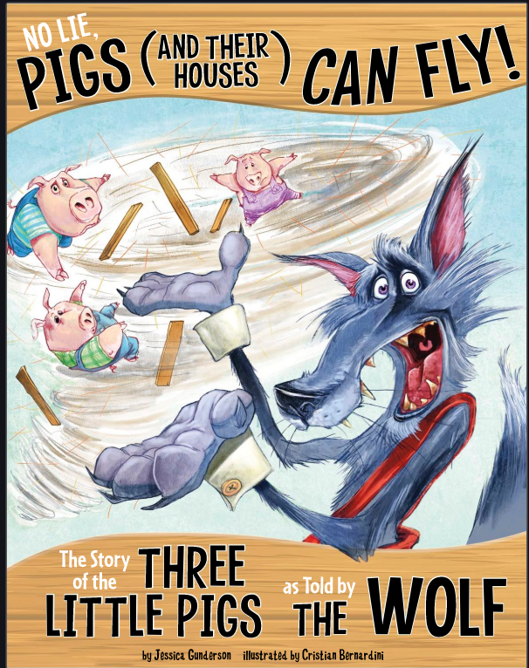  Read the book. Then, create a Venn Diagram comparing and contrasting both stories. You must include three examples in each part of the Venn Diagram.  *Post Venn Diagram to Seesaw if you can
ELAGSE2L1; ELAGSE2L4  Correct the following sentences by rewriting them on a separate piece of paper.  - we went to mr metz classroom to collect his students field trip forms he gave us a piece of candy as a thank you  - my mom’s car pulled up and I got in how was schools today she asked it was great I said then we drove home  - we went outsid for recess and i playd kickbal wif my friends. we did a lot of runing my teem won. | ELAGSE2RL1  Complete the Read Works Assignment: Characters and Their Pets | ELAGSE2RI2  Read the ReadWorks Article: Comparing Solids Article  Answer the comprehension questions  Create a learning poster highlighting the main points of what was read.  Share this poster with someone. Teach them about what you thought was important on the topic.  *Post a picture of your poster on Seesaw if you can

